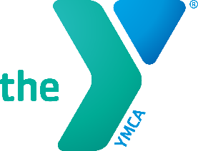 

**Job Title: Child Watch Attendant**

**Reports To:** Youth & Family Coordinator

**GENERAL FUNCTION**

Do you enjoy working with kids and creating a fun, safe space for them to play and grow? Join our team as a **Child Watch Attendant**!

You’ll care for children ages 6 weeks to 8 years while their parents use the Y—playing games, reading books, doing crafts, and keeping everyone safe and happy.

Requirements:

* Must be at least 16
* Friendly, dependable, and patient
* Great with kids and able to communicate with parents

Perks include:

* Free YMCA Membership
* Flexible Scheduling
* A fun, supportive team